# Aadhar No:632703364246

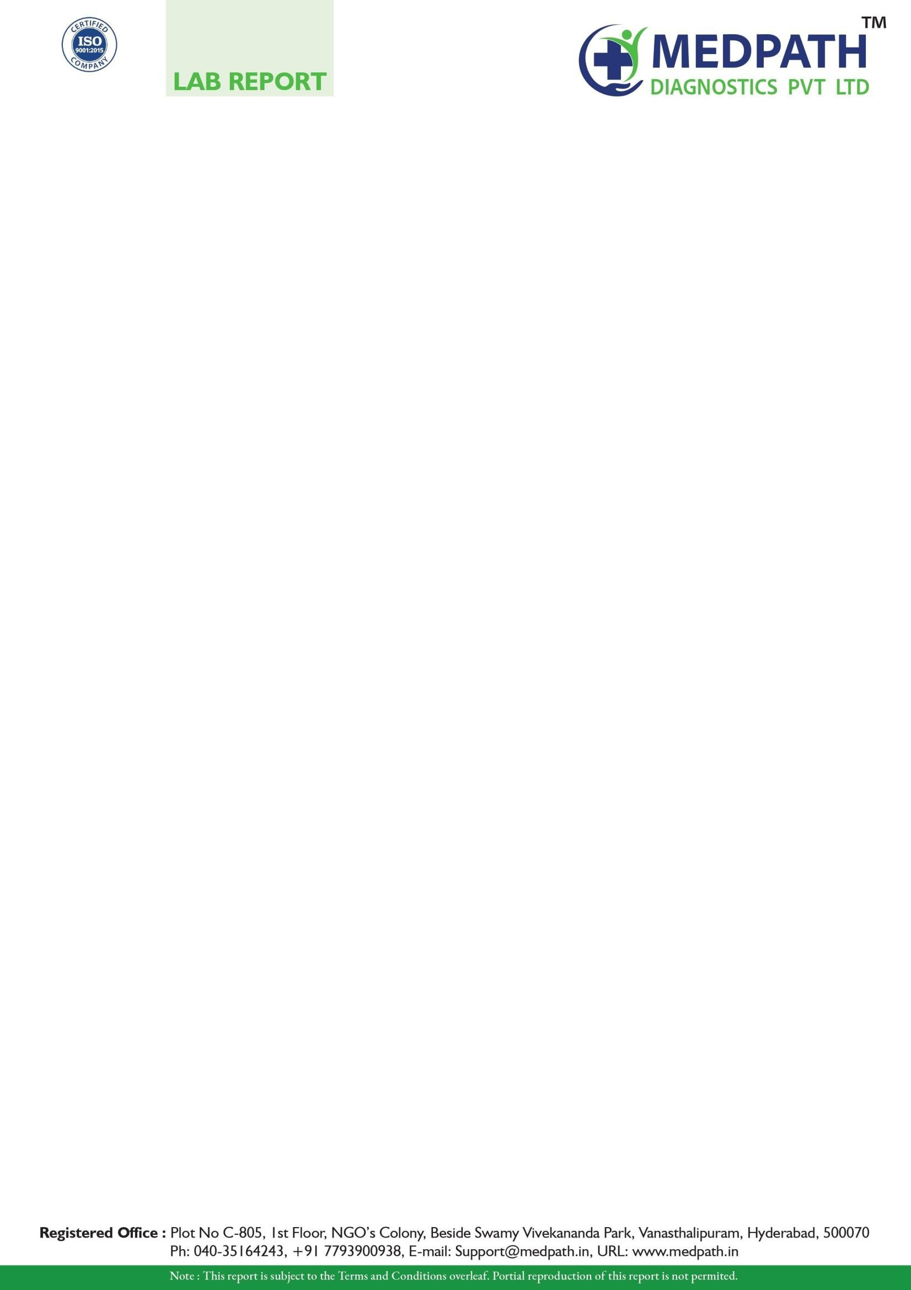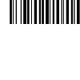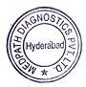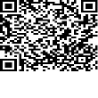

ITDOSE INFOSYSTEMS PVT. LTD.

|  |  |  |  |
| --- | --- | --- | --- |
| Name | : **Mr. Rudra Akhil** | Sample ID | : 20358664 |
| Age/Gender | : **27 Years/Male** | Reg. No | : 0162112220001 |
| Referred by | : Dr. SELF | MPD Code | : MP-TSF-650 |
| Referring Customer | : MM DIAGNOSTIC | Collected On | : 09-Mar-2022 12:05 PM |
| Sample Type | : Nasopharyngeal and Oropharyngeal Swabs | Received On | : 09-Mar-2022 03:15 PM |
|  |  | Reported On | : 10-Mar-2022 05:54 PM |

**MOLECULAR BIOLOGY**

**Test Name Results Units Ref. Range Method**

**SARS-CoV-2 (COVID-19) RT PCR**

**SARS COV-2 Detection** Negative Real Time - PCR

**Comment:**

Note: The results relate only to the specimens tested and should be correlated with clinical findings.

**What does CT mean?**

In the real time PCR assay a positive reaction is resulted by accumulation of fluorescent signal. The Ct (Cycle threshold) is defined as the number of cycles required for fluorescent signal to cross the threshold (ie exceeds background level). Ct values are inversely proportional to the amount of target nucleic acid in the sample (ie the lower the Ct level the greater the amount of target nucleic acid in the sample). WVDL real time assays undergo 40 cycles of amplification.

**Cts <= 24** are strong positive reactions indicative of abundant target nucleic acid ( Viral RNA ) in the sample Cts of

**25 to 28** are positive reactions indicative of moderate amounts of target nucleic acid ( Viral RNA ) Cts of

**29 to 37** are weak reactions indicative of minimal amounts of target nucleic acid ( Viral RNA ) which could represent an infection state.

Note: CT values differ from Kit to Kit, Lab to Lab, sample collection process and sample transportation/storage condition. Principle of assay is to determine the viral specific gene markers in collected sample. N-gene to detect all coronovirus strains and ORF1ab gene to confirm COVID- 19/SARS- CoV-2.

* Testing of referred clinical specimens was considered on the basis of approval from ICMR (**ICMR Code: MEDPLVT**)
* Negative results donot preclude SARS-CoV-2 and shouldnt be used as the sole basis for patient management decisions.Kindly repeat the test after 48/72hr if clinically suspected.
* A positive test results is only tentative, and will be reconfirmed by re-testing.
* Repeat sampling and testing of lower respiratory specimen is strongly recommended in severe or progressive disease.The repeat specimens may be considered after a gap of 2 to 4 days after collection of the 1st specimen for additional testing if required.
* A Positive alternate pathogen does't necessarily rule out either, as little is known about role of co-infections.
* False Negative results may be attributable to improper sample collection, improper transport, under anti-viral treatment.

# Correlate Clinically.

*** End Of Report ***

Page 1 of 1